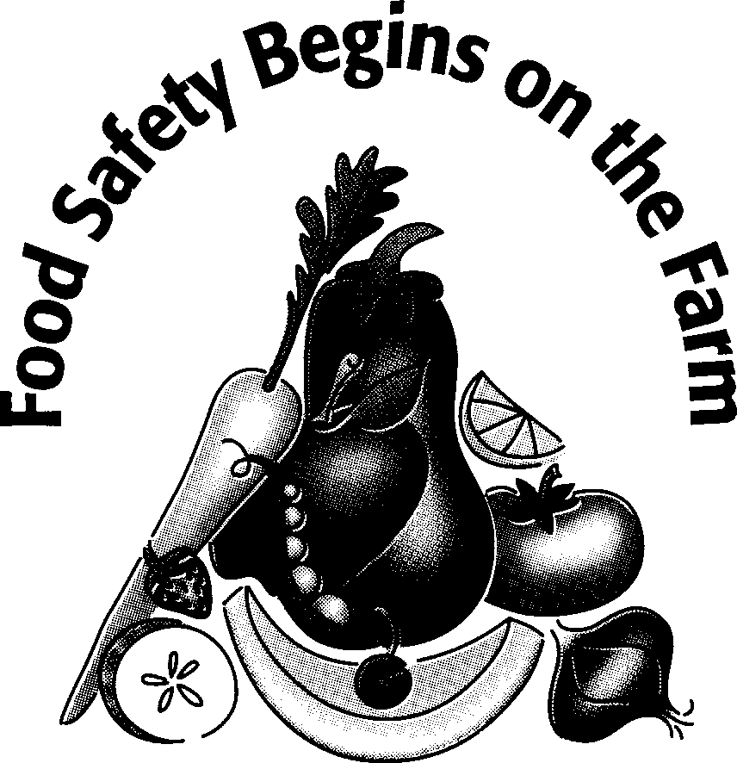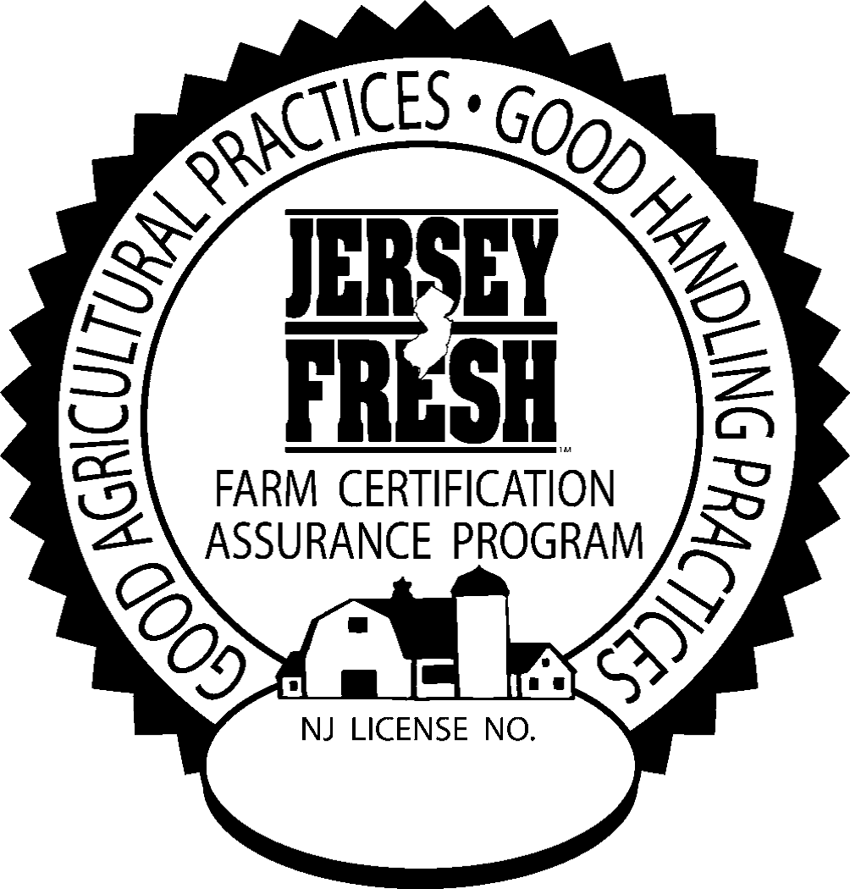

Mock Traceback Log

Name of Operation: Date:

Conducted By: Lot:

Product(s) traced:

Please see the food safety plan for overall traceback procedures.

Step Backward |  |  |  |  | Step Forward
Field No. | Harvest Date | Packing Date | Shipping Date | Amount of Product/Lot Code | Customer(s) Contacted | Product remaining at customer/Lot Codes | Disposition of product which could not be recalled
Sheet Reviewed by: Title: Date: November 2018

