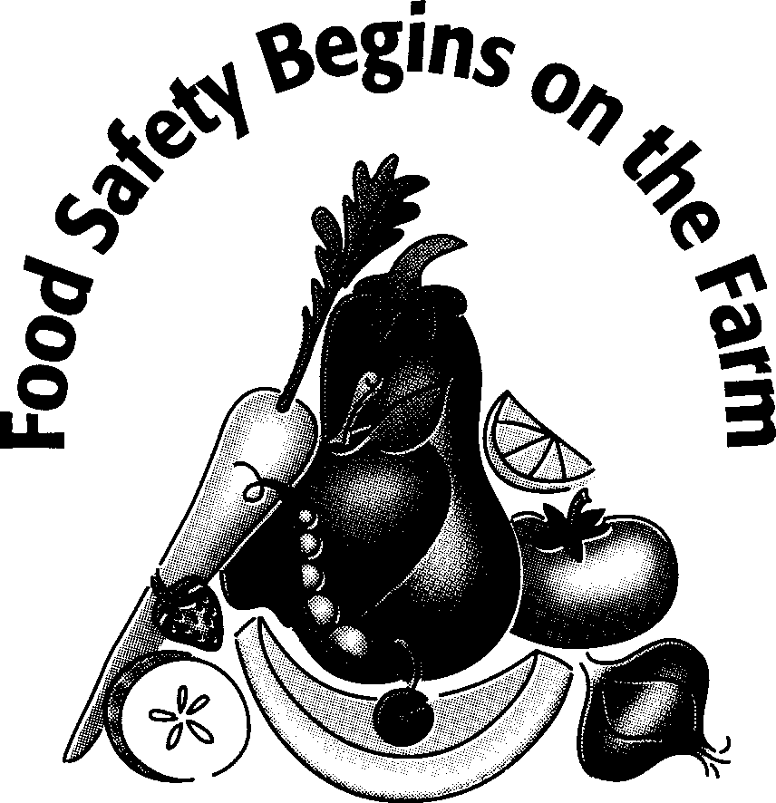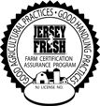

Pre-Harvest Assessment Log
Questions | YES | NO | N/A | Corrective Action | Initials
Are Toilet and wash facilities
properly located?
Is potable water available for workers?
Are harvest containers available,
clean, well located and protected?
Is harvest equipment available and
in good condition?
Are disinfection containers for
knives available?
Is there evidence of unauthorized entry in the crop area and if so, has it been investigated?
Is there evidence of domestic or
wild animal crop damage?
Is there evidence of physical
contamination in the crop area?
Are fuel and chemicals which might contaminate crop areas isolated?
If areas are contaminated are they
isolated for “no-harvest”?
Are there any other notable sources of biological or physical contamination such as dump sites, manure, burning debris, water that
may affect food safety?
Is transportation equipment clean
and available?

Sheet Reviewed by: on
(Management Signature) (Date)
November 2018

