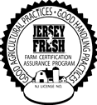

Restroom & Toilet Facility Maintenance Log
Location:

Date | Toilet & Hand Washing Facilities |  | Soap |  | Single- use Paper Towels |  | Toilet Paper |  | Trash Can |  | Potable Water |  | Employee’s Initials
 | Checked | Cleaned | Checked | Filled | Checked | Filled | Checked | Filled | Checked | Emptied | Checked | Filled

Sheet Reviewed by: on
(Management) (Date)
Note: Use a different sheet for each facility
November 2018

